Bring it on

Set up build triggers so that the task is performed every 5 minutes

* Launch tests not later than 5 minutes after committing in git
* Every workday at midnight

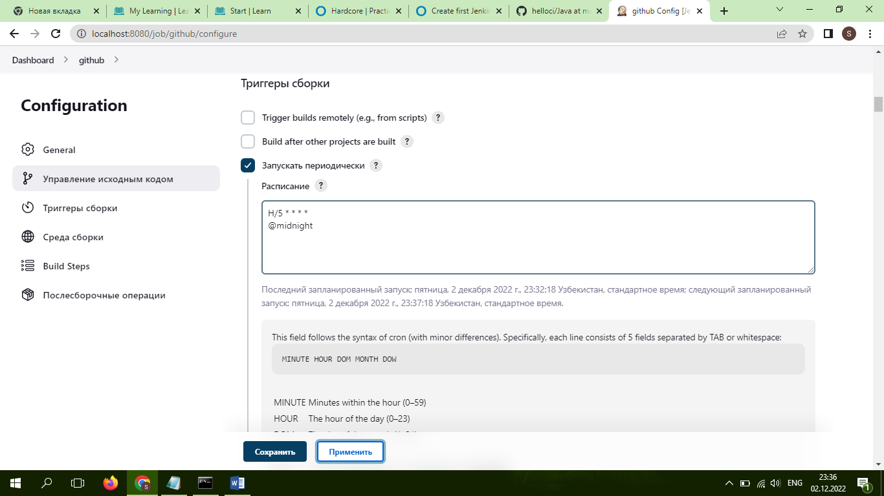**Done**